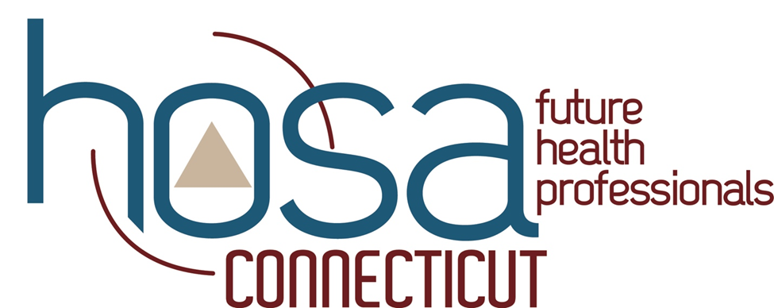
2025-2026 Pin Design Contest
Guidelines:
- The pin must say “Connecticut HOSA” or “CT HOSA”
- The design must be original artwork (you cannot copy anyone else's work from the internet or use AI to design the pin)
- The pin must depict something that represents Connecticut as well as HOSA
- The pin will be 1.5 inches in diameter, and the print must be easy to read
- A maximum of 6 colors may be used in your design
- Each member can only submit 1 design
- Submission of your design must be in the form of a high-resolution PNG, JPEG, or PDF file
- The file should be emailed to stateadvisor@cthosa.org by January 30th, 2026, at 11:59 pm to be considered. Please include the following as the subject of your email: “CT HOSA-Future Health Professionals APPLICATION FOR 2025-2026 CT HOSA State Pin Contest”
- The winning design will be turned into an enamel pin that will be traded at this year’s ILC in Indianapolis, Indiana. The winner will be announced at SLC on Saturday, March 14th, 2026, at Waterbury Career Academy
- Judging for the winning pin design will be completed by the state advisor and the current state officers
If you have any questions, please contact Jennifer Freese, CT HOSA State Advisor at stateadvisor@cthosa.org
CT HOSA Pin Design Contest Rubric
Criteria | Excellent | Good | Fair | Poor
Creativity and Originality | Unique, imaginative concept that stands out and feels fresh. | Creative idea with some original touches. | Lacks originality. | Uninspired or copied design.
Visual Appeal | Eye-catching, well-composed, and aesthetically pleasing. | Looks good with minor design inconsistencies. | Feels unbalanced or visually cluttered. | Visually unappealing and messy.
Concept and Meaning | Clear theme or message that resonates and tells a story. | The thematic idea is mostly clear and meaningful. | The theme is weak or ambiguous. | No clear theme, story, or concept.
Design for Production | Practical for pin production (size, line thickness, color separation, etc.) | Mostly suitable for production with minor adjustments needed. | Some production issues (eg, too detailed or poor contrast). | Not feasible to manufacture as a pin.
Use of Color | Excellent palate, great contrast, and harmony. | Good color choices, but a few areas could be improved. | Acceptable colors, but not very cohesive or appealing. | Poor or clashing color choices.
Line Work and Clarity | Crisp clean lines; easy to interpret even at a small scale. | Mostly clean with minor clarity issues. | Lines are rough or lose detail at the pin size. | Messy or unclear lines.
Original Execution | Shows effort, skill, and great attention to detail. | Good execution with some polishing needed. | Average effort or skill; could use refinement. | Sloppy, rushed, or low-effort execution.
WOW Factor | Truly memorable; would make people want to wear or collect it. | Interesting and likeable. | Mild impact; doesn’t leave much of an impression. | Forgettable or confusing.

